**PROJECT ON DIGITAL MARKETING**

**Name: KAVIYA . A**

**Team Members:**

Kaviya .A(53B3EA0AC66CF038C1843AEC81EBB088)(**TEAM LEAD)**

Jayalakshmi .V (46BCC663F4D7D3C98BF4DCC20ED189CE)

Priyadharshini.V (32F359FCF0B64EE8494421093502087D)

Seemarani Maharana . S (187F6B892DAA3A18E064B29FD0828C2F)

Sivaparkavi .R (280DEDE5DBA1562B36D45959DC6CFEA0)

**TEAM NM ID**: NM2023TMID03413

**DEPARTMENT**: B.E. Computer Science and Engineering – Final Year

**COLLEGE: 8151**- Dhanalakshmi Srinivasan Institute of Technology Samayapuram ,Trichy

**NAANMUDHALVAN COURSE**: Digital Marketing

PROJECT DESCRIPTION

**Project Title**: Wordpress - Blogging

**Blog Name:** The Power of Computer Science and Engineering

**Category : “** Education”

**Email :**  cseshiningengineers@gmail.com

**Password :** 210211sks

**Target Audience**: All(Men , Women and Adults)

**WordPress Blog URL :** [**https://cseshiningengineers2.wordpress.com/2023/10/18/the-power-of-computer-science-and-engineering**](https://cseshiningengineers2.wordpress.com/2023/10/18/the-power-of-computer-science-and-engineering)

**Recorded video:** [**https://youtu.be/TTnfKiWhlho**](https://youtu.be/TTnfKiWhlho)

**Post into Social Media Website :-**

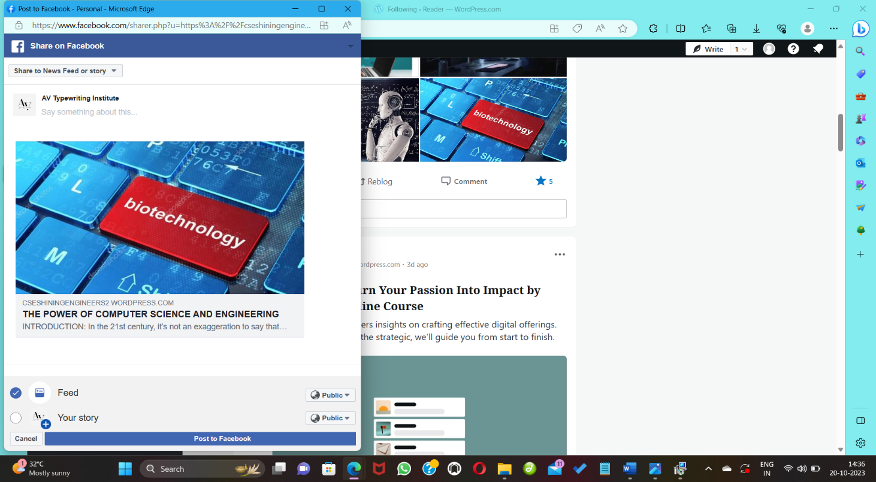

**Documentation:**

**Project Description:**

In this project, we aim to create a dynamic and user-friendly blog using the WordPress platform. Our goal is to design an appealing and responsive website that not only showcases compelling content but also offers a seamless user experience. This WordPress blog will serve as a platform to share valuable information, engage with the audience, and establish an online presence effectively.

**Steps:**

Navigation

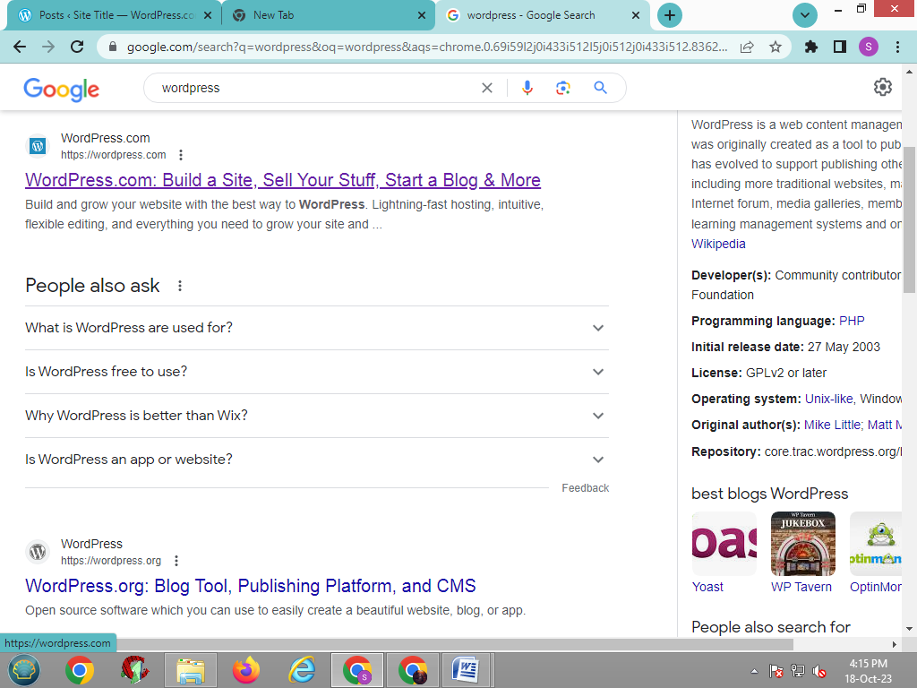

Login into wordpress

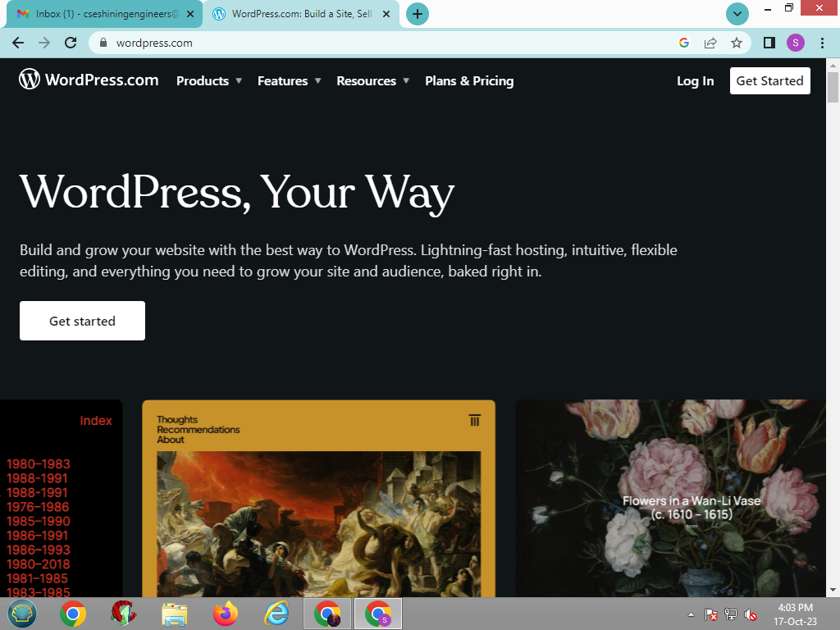

Choose my domain Later

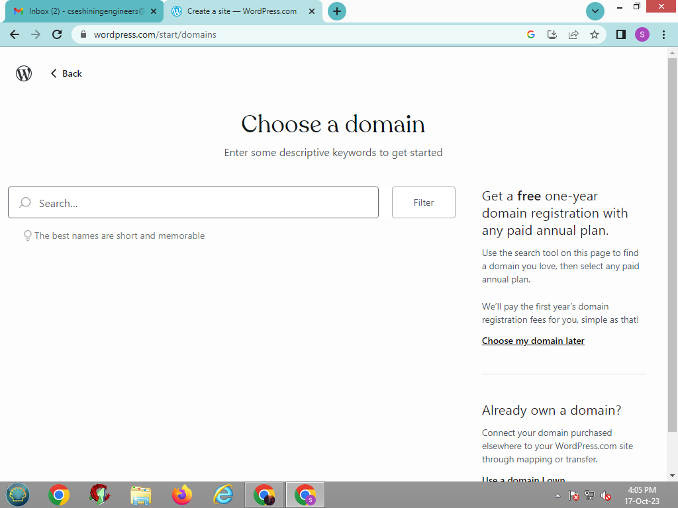

Select a free domain

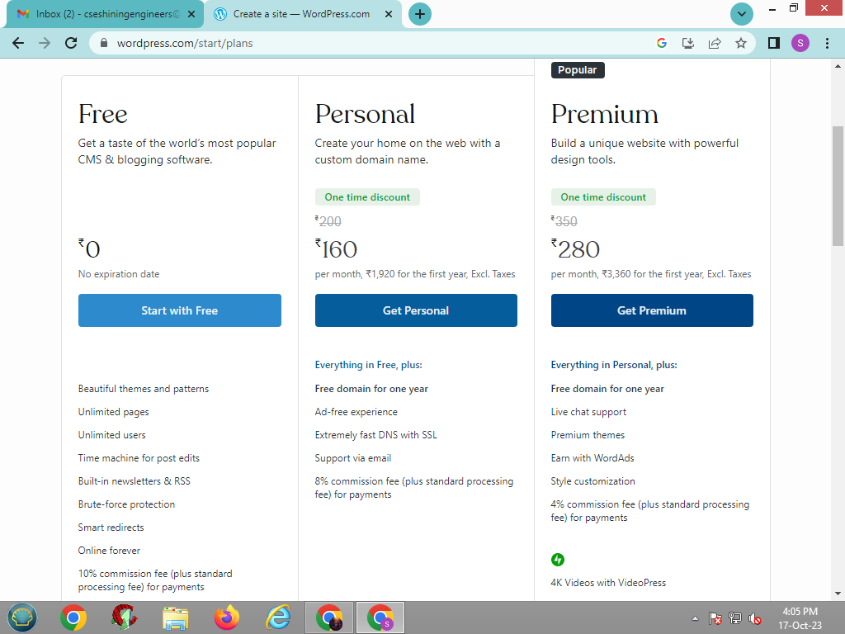

Launch site:

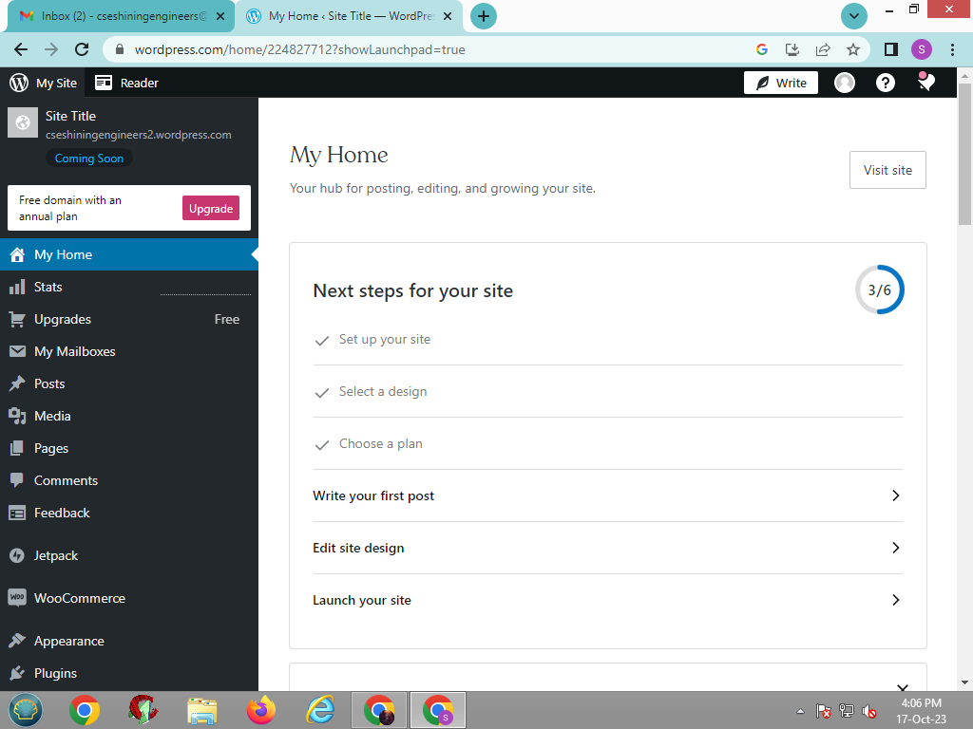

Select Posts > add a new Post

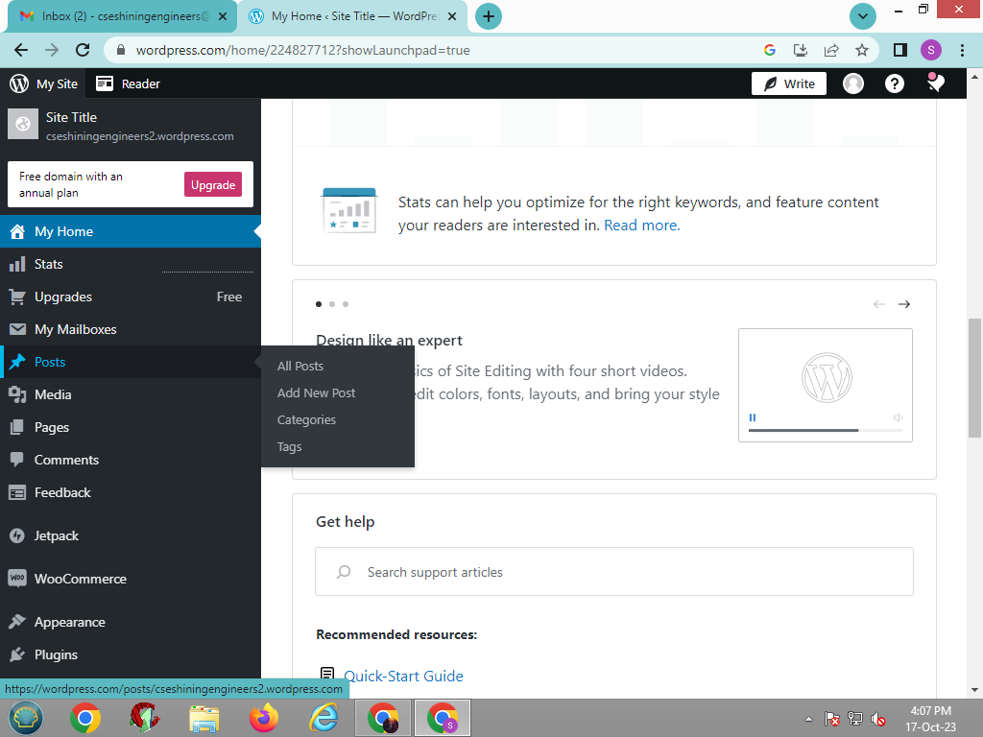

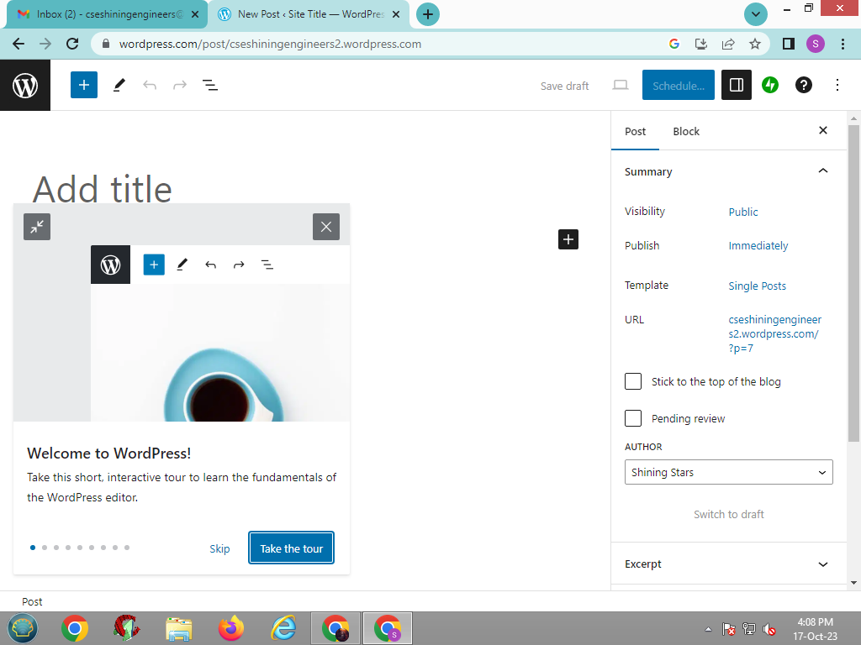

Search Copy ai: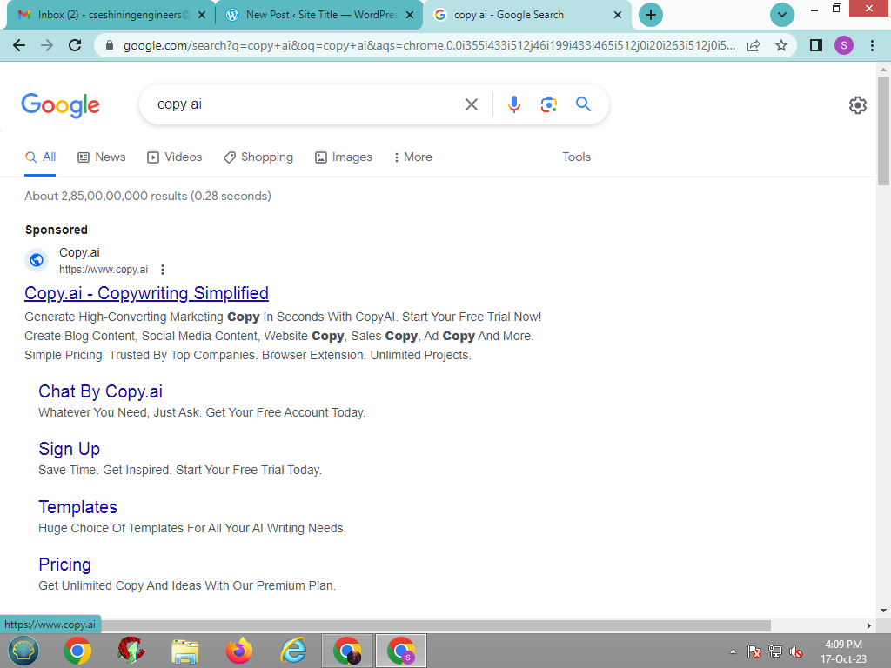

Sign up copy ai:

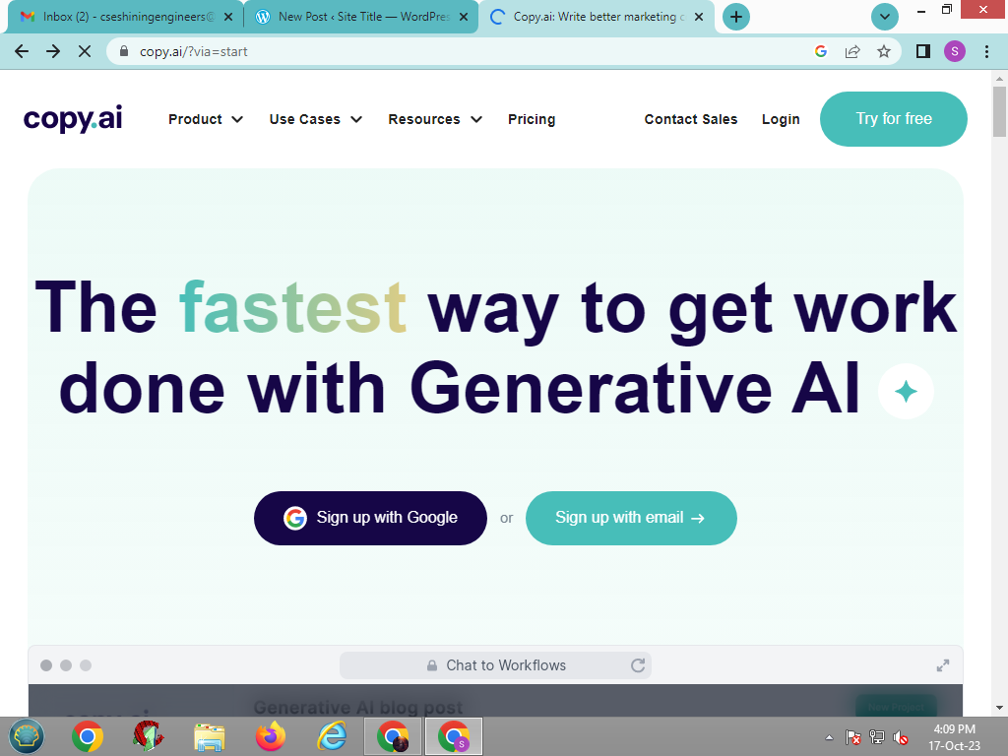

Type the blog Title > after copy ai generated the blog > click copy

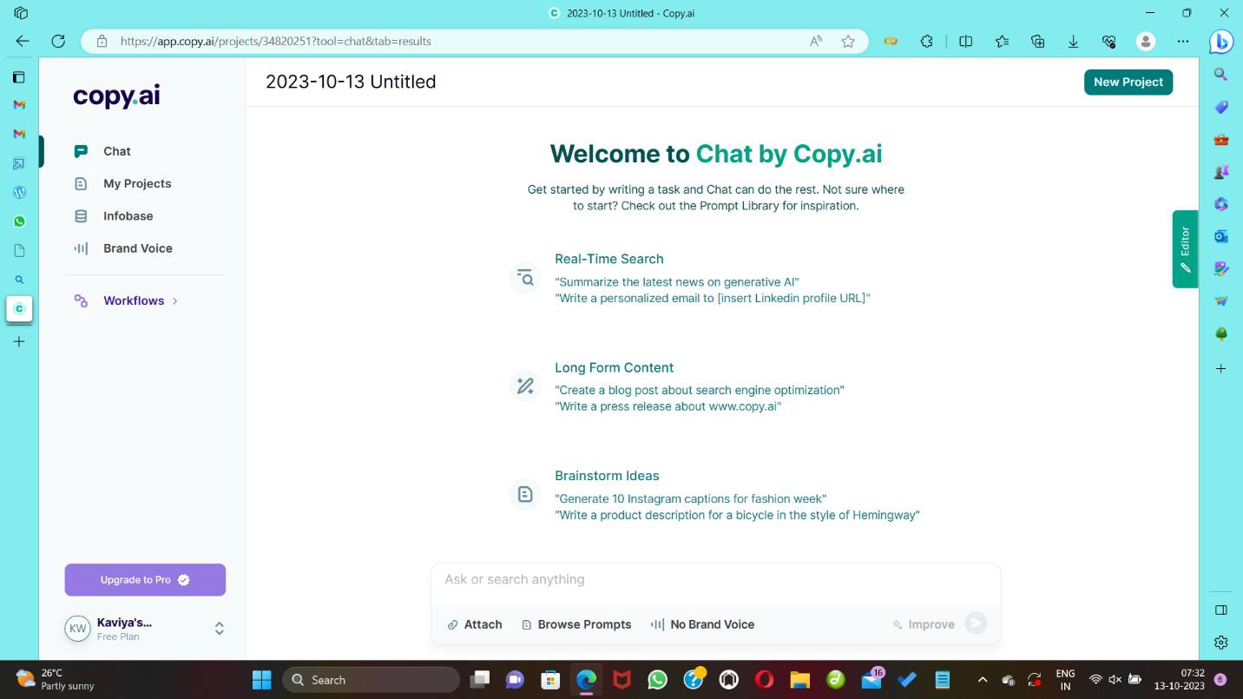

Search Grammarly and sign in:

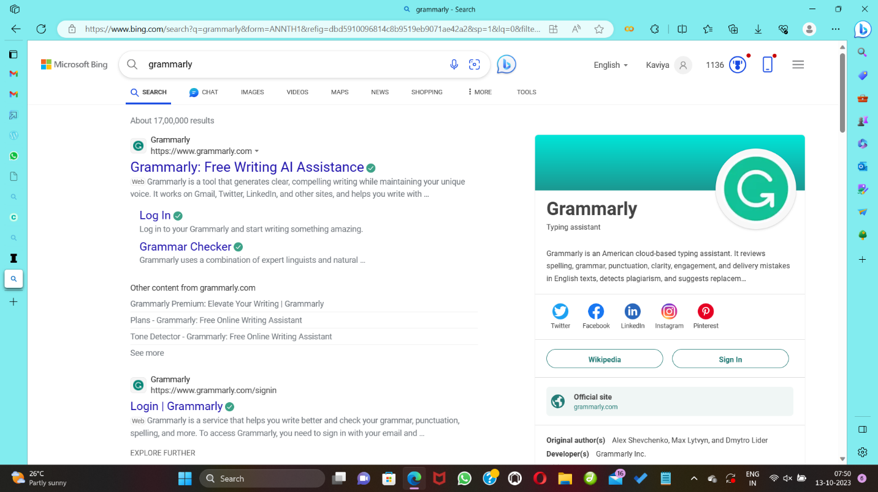

Paste text from copy ai:

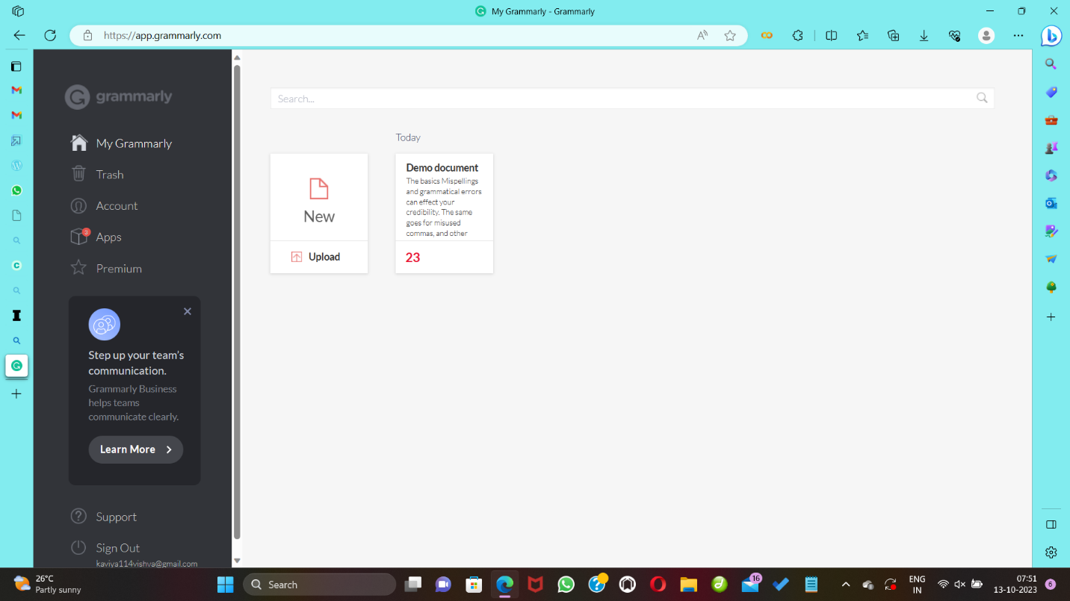

Set Goals – Check Grammar

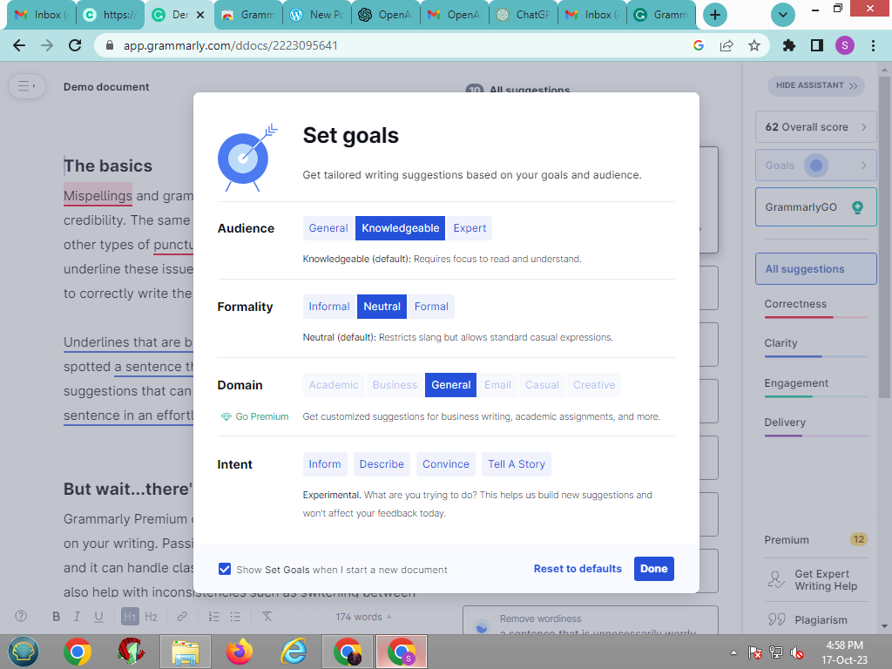

Copy title and paste it in blog:

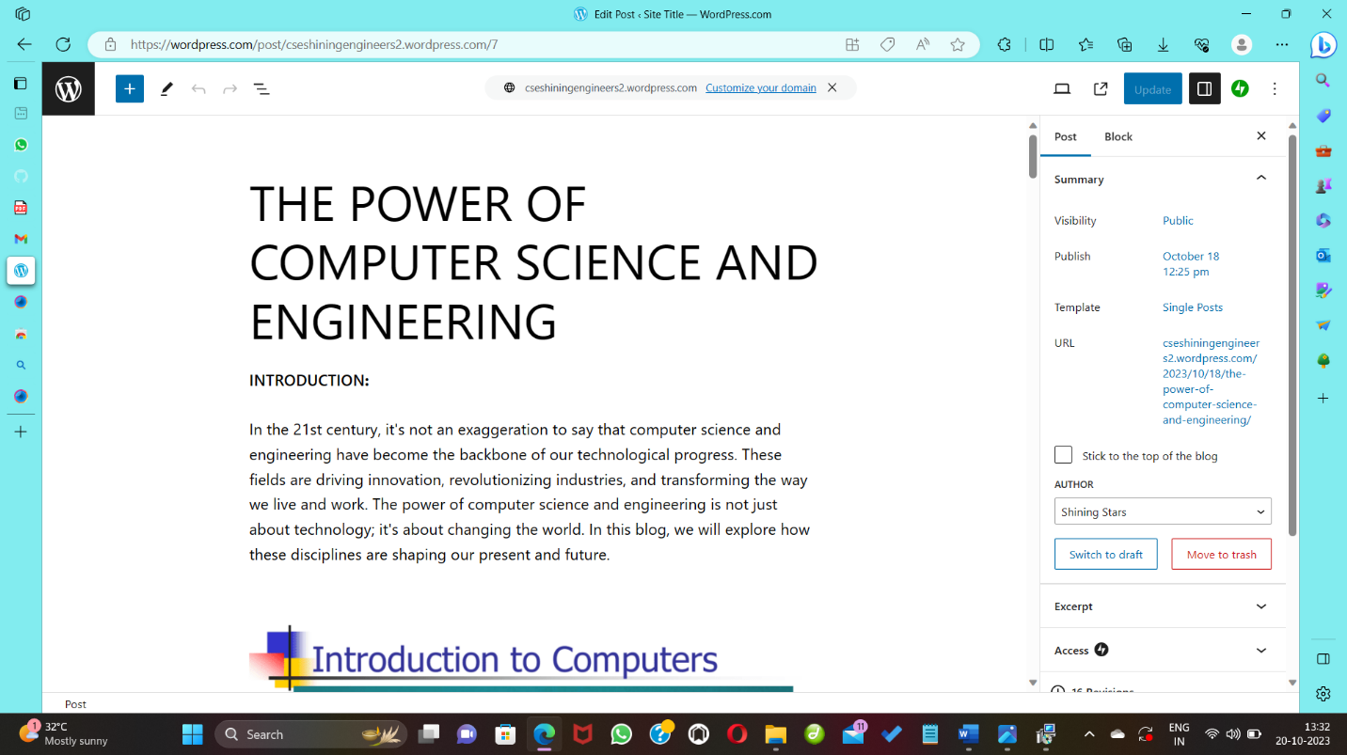

Copy the intro section and paste it in blog:



Add Heading using the heading button:

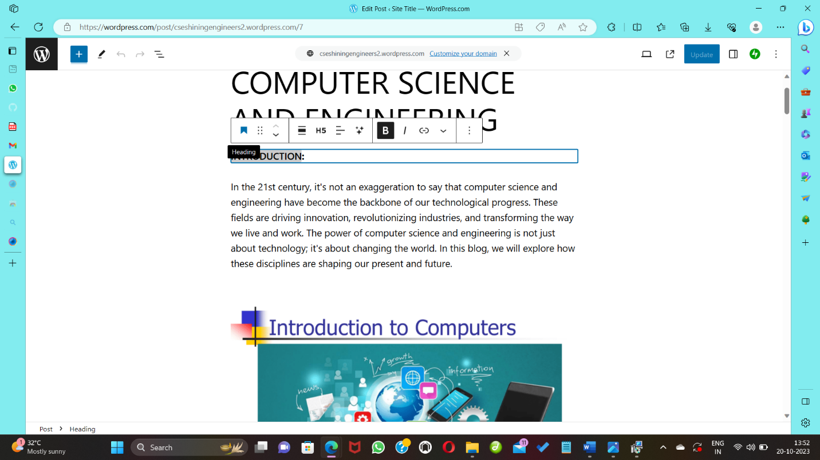

Copy all the Content from Grammarly:

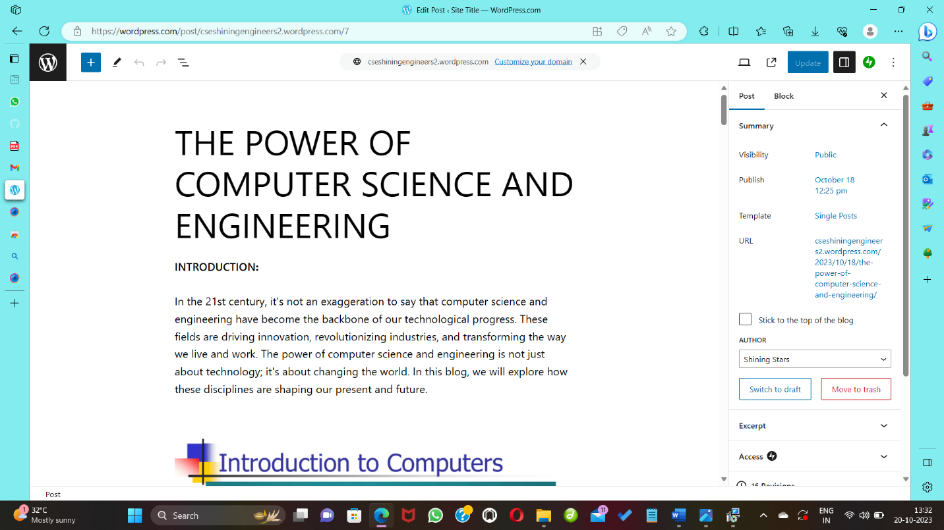

Add Categories, Tags and Featured image:

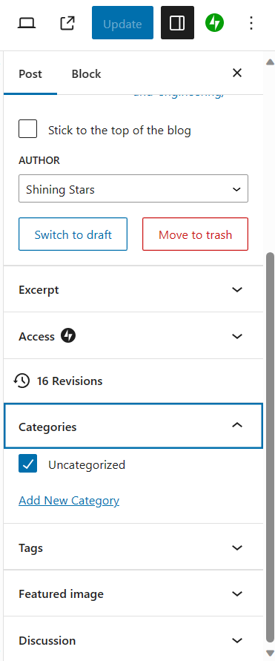

Click publish Button:

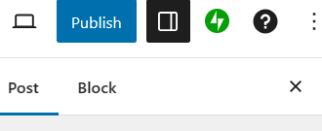

Output:

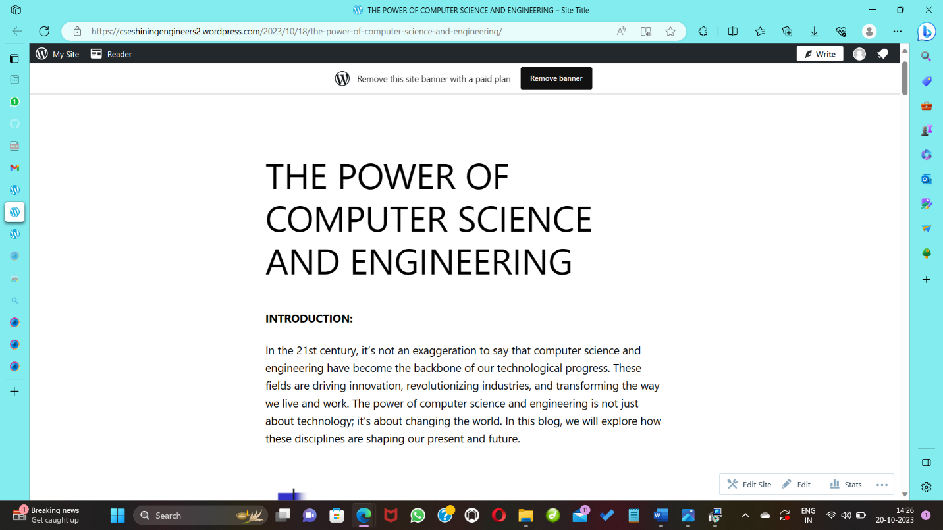

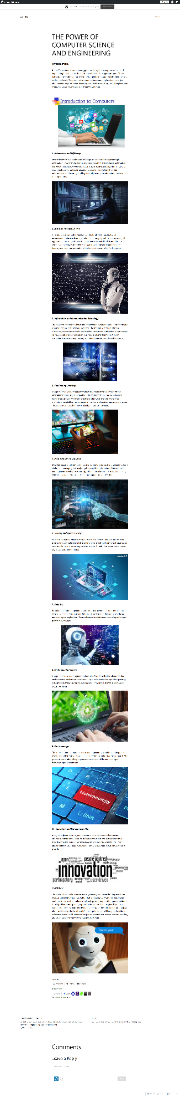Output:

Promote the blog on Social Media:

